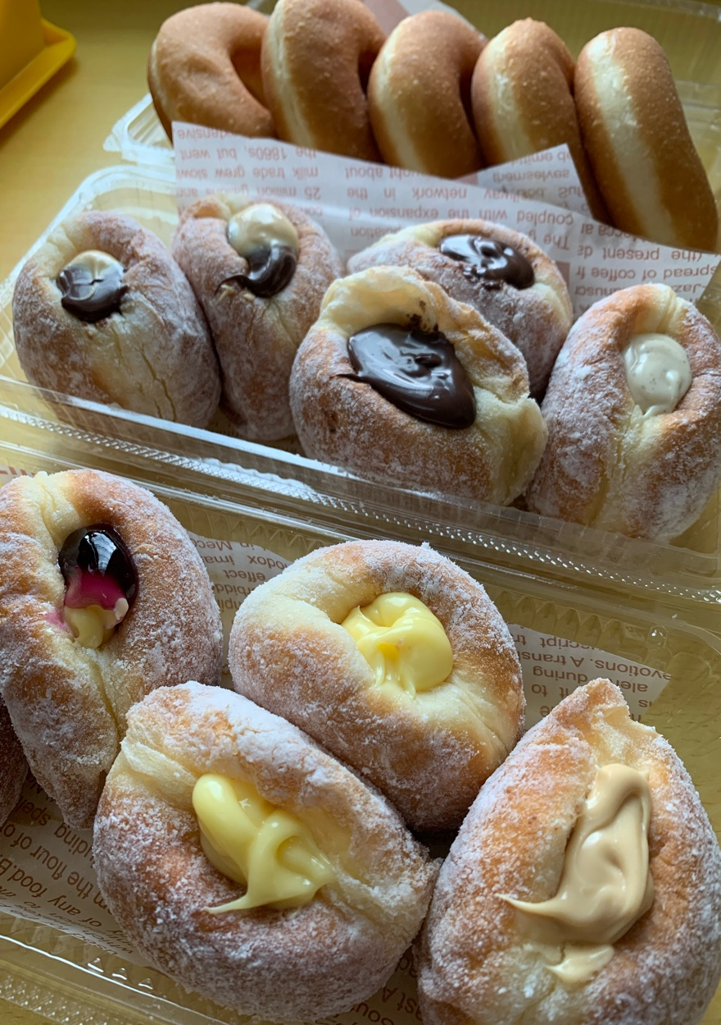

**Filling Creme Custard (Freshmade )**

250ml susu full cream

*1biji kuning telur

*1biji telur

*40gm gula pasir halus/castor

*20gm tepung jagung

10gm butter

1sdt vanila

Secubit garam

1-satukan bahan bertanda * dalam bekas,gaul kan sebati mengunakan whisk sehingga menjadi pasta

2-panaskan susu fullcream, ,lepastu tuang susu ke dalam adunan pasta(no1).whisk laju sehingga sebati, dan tuang semula ke dalam periuk letak butter/vanila/garam whisk masak lagi semula sehingga kental.

Siap.

Sukatan diatas biasanya boleh pipe dlm bomboloni dalam 20biji kalau nak lebih just double kan sukatan diatas.

**nak bagi nampak warna custard kuning boleh letak setitik egg yellow ke dalam adunan pasta(no1).kalau tak nak letak pun tak apa cuma warna agak pucat sedikit .

Boleh Mix dengan perisa perisa lain seperti Fruit Filling , Bluebery- Strawbery - Manggo dan lain lain .

*****ENGLISH TRANSLATE 👇🏻👇🏻👇🏻

**Filling Creme Custard (Freshmade)**

250ml full cream milk

*1 egg yolk

*1 egg

*40 gm fine granulated sugar/castor

*20gm corn flour

10 grams of butter

1 tsp vanilla

A pinch of salt

1- put together the ingredients marked * in a container, mix well using a whisk until it becomes a paste

2-heat the full cream milk, then pour the milk into the pasta mixture (no1). Whisk quickly until combined, and pour it back into the pot, put butter/vanilla/salt and whisk again until thick.

Ready

The measurements above can usually be piped in bomboloni in 20 pieces if you want more, just double the measurements above.

** if you want to see the color of the custard yellow, you can put a drop of egg yellow in the pasta mixture (no. 1). If you don't want to put it, it's okay, just a little pale

Can be mixed with other flavors such as Fruit Filling, Blueberry-Strawbery-Mango and others.